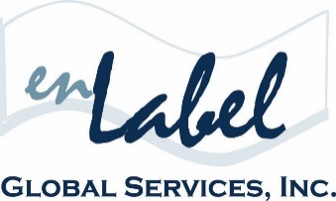
FOR IMMIDEATE RELEASE
Media Contact
Christine Tournas
enLabel Global Services
(617) 419-2400
ctournas@enlabel.com

ENLABEL GLOBAL SERVICES TO HOLD
INTERACTIVE PANEL DISCUSSION AT THE FOURTH ANNUAL
MEDICAL DEVICE GLOBAL LABELING STRATEGIES CONFERENCE

August 9-11, 2016 | Minneapolis, MN

BOSTON, June 2016. enLabel Global Services is the first-time Bronze Sponsor of the Fourth Annual Medical Device Global Labeling Strategies Conference, hosted by Marcus Evans, on August 9-11, in Minneapolis, Minnesota.

The conference will focus on designing flexible labeling systems to manage global regulatory requirements, adopting precise language that is easily translatable and culturally transferable, enhancing labeling processes and protocols to achieve compliance with impending global UDI requirements, centralizing data storage to create control within labeling strategies, in addition to analyzing cost-saving opportunities to determine practicality per product, resource allocation and market of operation.

Ken Legault, VP Sales & Business Development, enLabel Global Services, accompanied by Angie Kilgore, Quality Assurance Manager, Transplant Diagnostics at Thermo Fisher Scientific, will head a panel discussion on Effectively Managing Data Changes within Automated Systems. This interactive session will highlight how to designate ownership of automated systems to enable real-time data updates, leverage the Source of Truth to ensure data accuracy, establish protocols to verify data validity, and expediting data changes throughout automated systems to reduce cycle times.

Other industry experts, regulatory bodies and standards organizations will also provide professional insight via engaging presentations, specialized breakout sessions and panel discussions.

For additional event information, please visit, www.marcusevans.com or www.enlabel.com.

# # #

About enLabel Global Services
Founded in 2005, enLabel Global Services has completely changed the pace of the global enterprise packaging industry, by providing the World’s only end-to-end Integrated Packaging Management (IPM) Software Platform. Headquartered in the historical North End of Boston, MA, enLabel Global Services is a Technology and Consulting Services Company that works diligently with manufacturers and distributors in the Medical Device, Biotech, Pharmaceutical, Aerospace and Petro/Chemical industries. With a state-of-the-art streamlined approach to the global packaging process, enLabel is an

